SCREC XENIUM- 2K19
A National Level Technical, Cultural & Sports’ Congregate
On 12th and 13th March 2019
REGISTRATION FORM

Name : __________________________________________

Branch : __________________________________________

Year : __________________________________________

Institution : __________________________________________

Participating
Events : __________________________________________

Phone No : __________________________________________

Email : __________________________________________

Address for Communication

___________________________________________________________

___________________________________________________________

____________________________________________________________

Place: | Signature of the Applicant
Date:

Chief Patrons
Sri. Chundi Venu Gopal
Secretary & Correspondent
Sri. Chundi Vijaya Saradhi
President
Smt. Lalitha Devi
Vice president

Patron
Dr. K.Ramanjaneyulu
Principal

SCREC XENIUM - 2K19
A National Level Technical, Cultural & Sports’ Congregate
On 12th and 13th March 2019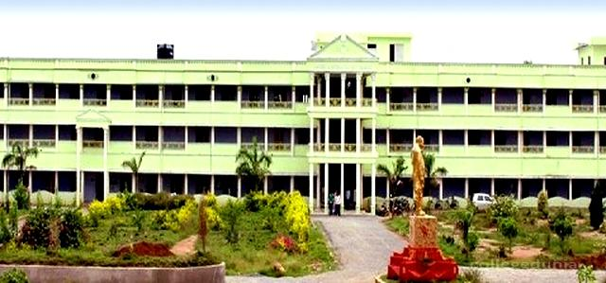

Organized by

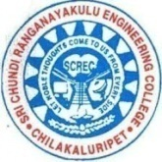

SRI CHUNDI RANGANAYAKULU ENGINEERING COLLEGE
(Approved By AICTE, Affiliated To JNTUK)
Ganapavaram,Chilakaluri Peta,A.P-522619
Ph.No:8019939669,9440257521
Web site:www.crenggcollege.com

ABOUT THE INSTITUTION
SriChundiRanganayakuluEngineeringCollege popular-ly known as SCREC, was established in the year 1999. It is the flagship institute among the various educational institutions started by the well known philanthropist Sri Chundi Ranganayakulu whose primary objective is to establish and manage a variety of educational Institutions with high quality and to produce quality human resources for the service of the society. The College is situated in a spacious 26 acres of land with a built up area of 18006 Sq.m. It has five branches in its undergraduate program, i.e., E.E.E., M.E., E.C.E. C.S.E. and Civil along with the Post Graduate MBA and MTECH courses.All departments are teamed with well-qualified and experienced teaching staff as per the norms of A.I.C.T.E. All the technical staff are well qualified and dedicated.

PROGRAM SCHEDULE
DAY-1  (12th March) | SPORTS & TECHNICAL
DAY-2  (13thMarch) | TECHNICAL & CULTURAL

REGISTRATION FEE

- Registration for Technical and Non-Technical
Student : Rs 100/-(per head)
- Registration for Sports Team : Rs 100/-(Team)

IMPORTANT DATES
- 12th – 13thMarch2019

- Last Date For Submission of Applications:
09th March 2019

- Pre-Registration &Spot Registration is also Available

HOW TO APPLY AND REGISTER
Advance copy of Registration formmay be submitted through e-mail to:-
CSE:cr.cse19@gmail.com
ECE:screcece@gmail.com
EEE:screceeedepartment02@gmail.com
CIVIL:screccivilhod@gmail.com
MECH:screcmech1234@gmail.com
MBA:Subhanippp@gmail.com

ELIGIBILITY
The students of CSE,IT,ECE,EEE,MCA& Research Scholarsfrom AICTE approved Colleges.

CONTACT
V.Paul(CIVIL):8309604561
V.Sai(MECH):9160347160
K.Bramaiah(ECE):9705155286
B.Hari Krishna(CSE):9550652481
K.Siva Krishna(EEE):8790206843
Sk.Subhani(MBA):7842538539

ADDRESS FOR CORRESPONDENCE
Sri Chundi Ranganayakulu Engineering College,
Ganapavaram, ChilakaluriPet-522619
E -mail: screnggcollege@yahoo.in
Ph.No : 8019939669,9866119251

